Physics 30 1997 January

Numerical Response

- A horizontal force of 207 N acts on a 7.80 kg bowling ball for 0.520 s. The change in the ball's speed is __________ m/s.

(Record your three-digit answer in the numerical-response section on the answer sheet.)

Use the following information to answer the next two questions.

A 0.50 kg steel block starts from rest at point X, which is 4.0 m above the ground, and slides along a steel rail. Assume that the steel is frictionless. The path of the block as it slides along the rail is shown below.

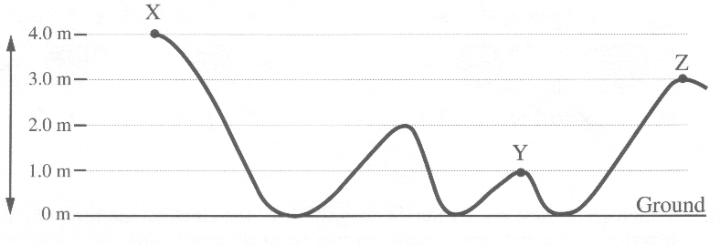

- The speed of the block at point Z is
A. 4.4 m/s
B. 4.9 m/s
C. 8.9 m/s
D. 14 m/s

- Assuming that the potential energy of the block is zero at ground level, then the total mechanical energy of the block at point Y is
A. 4.9 J
B. 9.8 J
C. 15 J
D. 20 J

- A single stationary railway car is bumped by a five-car train moving at 9.3 km/h. The six cars move off together after the collision. Assuming that the masses of all the railway cars are the same, then the speed of the new six-car train immediately after impact is
A. 7.8 km/h
B. 8.5 km/h
C. 9.3 km/h
D. 11 km/h

- When the electron and the proton in a hydrogen atom are 5.3 x 10⁻¹¹ m apart, the magnitude of the electrostatic force on the electron is
A. 4.3 x 10⁻²⁰ N
B. 4.3 x 10⁻¹⁸ N
C. 8.2 x 10⁻¹² N
D. 8.2 x 10⁻⁸ N

- Which graph best represents the magnitude of the electrostatic force, F, as a function of the distance, r, between two point charges?
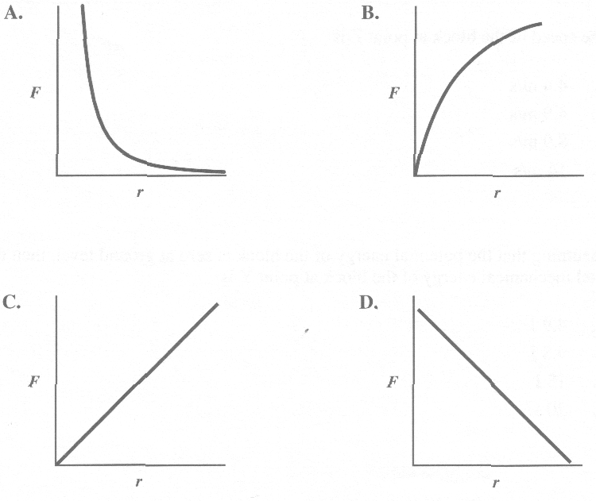
- The field resulting from a positive point charge and a negative point charge is best represented by
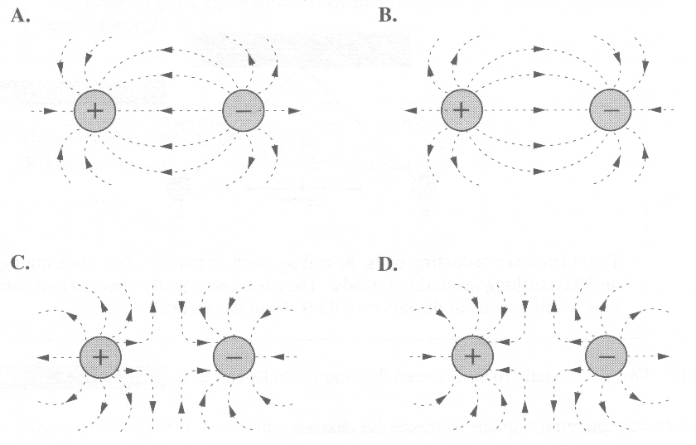

Use the following information to answer the next question.

Two parallel metal plates are 1.5 cm apart and are maintained at a potential difference of 2.5 x 10² V.

- The magnitude of the electrical force on an alpha particle when the alpha particle is between the plates is
A. 5.3 x 10⁻¹⁵ N
B. 2.7 x 10⁻¹⁵ N
C. 5.3 x 10⁻¹⁷ N
D. 2.7 x 10⁻¹⁷ N

Use the following information to answer the next three questions.

Electrostatics

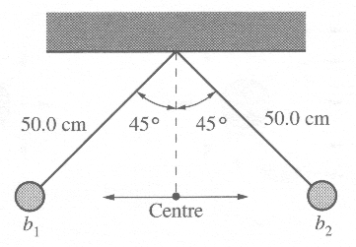
Two identical conducting balls, b₁ and b₂, each of mass 25.0 g, are hanging on 50.0 cm-long insulating threads. They become equally charged and come to rest with angles of deviation of 45.0º from the vertical.

- The electrostatic force between the charged balls can best be described as
A. an attraction due to dissimilar charges
B. a repulsion due to dissimilar charges
C. an attraction due to similar charges
D. a repulsion due to similar charges

- What is the tension in the thread that is supporting one of the balls?
A. 0.173 N
B. 0.245 N
C. 0.347 N
D. 9.81 N

- If the charge on b₁ is tripled and the charge on b₂ is reduced to one-third of its original amount, the angles of deviation from centre would
A. increase for b₁ and decrease for b₂
B. remain the same for both b₁ and b₂
C. increase for both b₁ and b₂
D. decrease for both b₁ and b₂

Use the following information to answer the next three questions.

The headlight of a car operates with an input power of 75.0 W and draws a current of 6.25 A.

Numerical Response

- The voltage supplied to the headlight is __________ V.

(Record your three-digit answer in the numerical-response section on the answer sheet.)

Numerical Response

- The number of electrons passing through the headlight every minute, expressed in scientific notation, is a.b x 10^{cd} electrons. The values of a, b, c, and d are _____, _____, _____, and _____ .

(Record all four digits in the numerical-response section on the answer sheet.)

Numerical Response

- The energy used by the headlight during 1.00 h of operation, expressed in scientific notation, is b x 10^{w} J. The value of b is _________.

(Record your three-digit answer in the numerical-response section on the answer sheet.)

Use the following information to answer the next three questions.

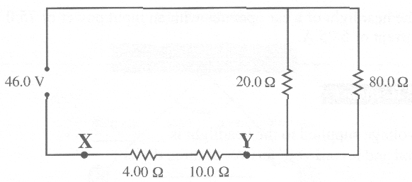

The potential difference between points X and Y is 21.5 V.

Numerical Response

- The equivalent resistance for the circuit is __________ Ω.

(Record your three-digit answer in the numerical-response section on the answer sheet.)

Use your recorded answer for Numerical Response 5 to solve Numerical Response 6.

Numerical Response

- The total current supplied by the 46.0 V power supply to the circuit is _________ A.

(Record your three-digit answer in the numerical-response section on the answer sheet.)

- The voltage drop across the 20.0 Ω resistor in the circuit is
A. 30.6 V
B. 24.5 V
C. 16.0 V
D. 1.53 V

Use the following information to answer the next three questions.

Lightning storms are one of the most spectacular phenomena in nature and play a key role in maintaining the electrical balance of Earth. One lightning strike occurred over a potential difference of 200 MV and transferred 12 C of charge to the ground in 0.010 s.

- The energy released by the lightning strike in this time interval was
A. 3.2 x 10⁻¹¹ J
B. 2.4 x 10³ J
C. 2.4 x 10⁹ J
D. 2.4 x 10¹¹ J

Use your recorded answer for Multiple Choice 12 to solve Numerical Response 7.

Numerical Response

- The power released in this lightning strike, expressed in scientific notation, is a.b x 10^{cd} W. The values of a, b, c, and d are _____, _____, _____, and _____ .

(Record all four digits in the numerical-response section on the answer sheet.)

- People inside a car are protected from the electric fields associated with lightning. Many parts of stereo components are contained in metal boxes. These two examples demonstrate that the electric field inside a closed metal container is
A. zero
B. opposite to the field outside
C. equal to the field outside
D. half the field outside
_____________________________

- Which of the following unit combinations is not equivalent to an ampere?
A. Watt/volt
B. Volt/ohm
C. Watt/ohm
D. Coulomb/second

- Energy is used to move a charge of 3.00 C through a circuit with a resistance of 1.00 x 10² Ω in 1.00 s. If the same amount of energy is used to throw a 1.00 kg ball vertically upward, the maximum height of the ball would be
A. 1.09 x 10⁻² m
B. 3.27 x 10⁻² m
C. 3.06 x 10¹ m
D. 9.17 x 10¹ m

- To boil three cups of water each day for one year using an old model of microwave oven costs $1.10. A new 750 W microwave oven boils one cup of water in 100 s. If the cost of energy is $0.0100/MJ, how much money will a consumer save by using the new microwave oven to boil three cups of water each day for one year? Assume in each case that the water is at the same starting temperature.
A. $0.28
B. $0.82
C. $1.38
D. $2.80

Use the following information to answer the next question,

Unit Combinations

I. J/C
II. N/(A·m)
III. T
IV. (N·s)/(C·m)

- Which unit combinations could be used correctly for a magnetic field?
A. I, III, and IV
B. II and III only
C. II and IV only
D. II, III, and IV

- An electric field of strength 1.5 x 10⁴ N/C is perpendicular to a magnetic field of strength 3.0 x 10⁻³ T. An electron moves perpendicular to both fields and is undeflected as it passes through the fields. The speed of the electron is
A. 2.0 x 10⁻⁷ m/s
B. 2.0 x 10⁻¹ m/s
C. 5.0 x 10⁶ m/s
D. 5.0 x 10⁷ m/s

- An ideal transformer steps down 25 000 V to 120 V for use in a house. Several appliances draw a total of 2 000 W from the 120 V side of the transformer. What is the current in the 25 000 V line?
A. 6.00 x 10⁻² A
B. 8.00 x 10⁻² A
C. 12.5 A
D. 16.7 A

- When two parallel conducting wires repel each other, the currents in the wires are
A. in opposite directions
B. in the same direction
C. oscillating in phase
D. oppositely charged

Use the following information to answer the next question.

Almost all electric guitars use devices called electromagnetic pickups. A guitar string is composed of metal that becomes magnetized by a permanent magnet found below the string. A coil of wire surrounds the permanent magnet.
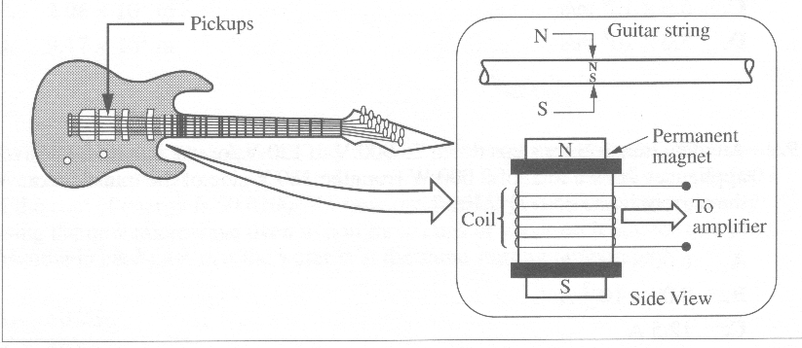

- When the string is plucked, a small current is produced in the coil of wire because
A. a potential difference is produced in the string
B. there is a current in the string that can be amplified
C. there is a charge buildup on the string
D. the string behaves as a magnet moving toward and away from the coil

- French high-speed trains operate using power lines that have an effective voltage of 25.0 kV and a frequency of 50.0 Hz. The maximum or peak voltage of the power lines is
A. 12.5 kV
B. 17.7 kV
C. 35.4 kV
D. 50.0 kV

- Which of the following diagrams best illustrates the magnetic field near a wire that carries an electron current out of the plane of the paper?
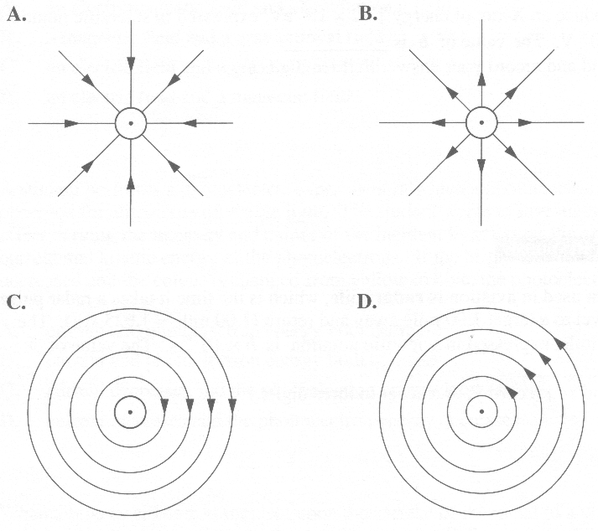

Numerical Response

- An electromagnetic wave has a frequency of 2.00 x 10 Hz. The speed of the wave in a vacuum, expressed in scientific notation, is b x 10' m/s. The value of b is ________.

(Record your three-digit answer in the numerical-response section on the answer sheet.)

- In a vacuum, the period of oscillation of a microwave with a wavelength of 2.5 cm is
A. 8.3 x 10⁻¹¹ s
B. 8.3 x 10⁻⁹ s
C. 1.2 x 10⁸ s
D. 1.2 x 10¹⁰ s

Numerical Response

- The minimum potential difference through which an electron must be accelerated to produce an X-ray of energy 1.62 x 10⁴ eV, expressed in scientific notation, is b x 10^{w} V. The value of b is __________.

(Record your three-digit answer in the numerical-response section on the answer sheet.)

Numerical Response

- A term used in aviation is radar mile, which is the time it takes a radar pulse to travel to a target 1.00 mile away and return (1.00 mile = 1.625 km). The radar mile, expressed in scientific notation, is b x 10^{-w} s. The value of b is ________.

(Record your three-digit answer in the numerical-response section on the answer sheet.)

Use the following information to answer the next question.

A technological application of quantum theory is the development of “electric eyes,” which can be used in automatic door openers or burglar alarms. A light beam shines across a door opening and causes the production of a current in a circuit. When the beam is broken, the current stops and a mechanism is triggered to open a door or sound an alarm.

- The operation of an electric eye is an application of
A. the Compton effect
B. the wave nature of matter
C. the photoelectric effect
D. Maxwell's electromagnetic wave theory

- To determine the speed of charged particles in a cathode-ray tube, Thomson balanced the forces produced by
A. an electromagnetic field and a gravitational field
B. a magnetic field and a gravitational field
C. an electric field and a gravitational field
D. an electric field and a magnetic field

- A student performs a photoelectric experiment in which a photoelectric current is observed for all colours of visible light. The student wants to investigate what effect varying the intensity and colour of the incident light has on the photoelectric current and kinetic energy of the photoelectrons. If the brightness of the light is decreased and the colour is changed from yellow to blue, the photoelectric
A. current and photoelectron energy both decrease
B. current and photoelectron energy both increase
C. current decreases and the photoelectron energy increases
D. current increases and the photoelectron energy decreases

- When a blue laser beam is incident upon the surface of the metal of a photoelectric cell, there is no photoemission. A second beam of radiation causes photoelectrons to be emitted. The second beam may consist of
A. ultraviolet radiation
B. infrared radiation
C. red laser radiation
D. microwave radiation

- A photon of energy 1.13 eV is emitted by a hydrogen atom when the electron “jumps” from
A. n=6 to n=3
B. n=3 to n=6
C. n=5 to n=2
D. n=2 to n=5

Use the following information to answer the next two questions.

Energy States of Chromium in a Ruby Crystal Laser
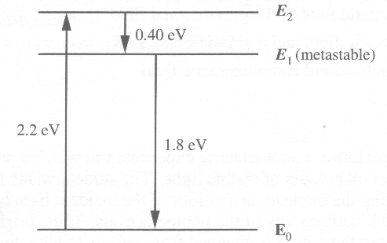
A laser can be made using a ruby crystal containing chromium (Cr) atoms. The lasing action can occur only after electrons in the chromium atoms are "pumped" from the ground state to state E₂ using strong flashes of light. The electron will then undergo a transition from E₂ to the ground state, E_{o}, or to the intermediate state, E₁.

Photons emitted by the electrons that have undergone transition from E₁ to E_{o} may strike other electrons at the E₁ state. This causes a new photon to be emitted along with the original photon. These photons are exactly in phase and moving in the same direction. The cumulative effect of this process creates the laser beam.

- What is the frequency of light emitted from the laser when the electron in the chromium atom goes from state E₁ to state E_{o}?
A. 9.7 x 10¹³ Hz
B. 4.3 x 10¹⁴ Hz
C. 5.3 x 10¹⁴ Hz
D. 1.1 x 10¹⁵ Hz

Numerical Response

- Flashes of light pump electrons in the Cr atoms from the ground state, E_{o}, to state E₂. The wavelength of these flashes of light, expressed in scientific notation, is b x 10^{-w} m. The value of b is ________.

(Record your two-digit answer in the numerical-response section on the answer sheet.)

Use the following information to answer the next three questions.

Photomultiplier Tube
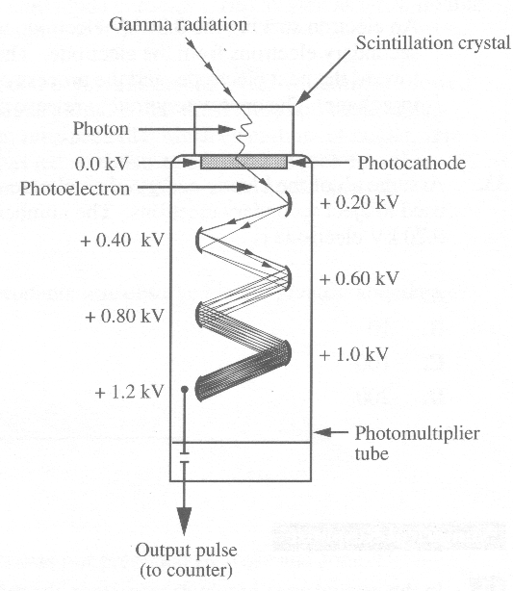

When the scintillation crystal is struck by gamma radiation, it emits photons with a wavelength of 4.93 x 10⁻⁷ m. Some of these photons strike the photocathode. As a result, electrons are ejected from the bottom surface of the photocathode. The work function of the photocathode is 2.10 eV.

- The maximum kinetic energy of the electrons ejected from the photocathode is
A. 6.7 x 10⁻²⁰ J
B. 3.4 x 10⁻¹⁹ J
C. 4.0 x 10⁻¹⁹ J
D. 7.4 x 10⁻¹⁹ J

- The electrons leaving the photocathode are attracted by the 0.20 kV electrode. The maximum speed they attain is
A. 8.6 x 10⁵ m/s
B. 8.4 x 10⁶ m/s
C. 7.0 x 10¹³ m/s
D. 2.1 x 10¹⁵ m/s

Use the following additional information to answer the next question.

Inner Workings of the Photomultiplier Tube

An electron striking the 0.20 kV electrode will use its energy to eject multiple secondary electrons from the electrode. The secondary electrons accelerate toward the next electrode, and the process continues along successive increases in voltage. The energy required to release a single electron is 40.0 eV.

- Assume all of the kinetic energy of an electron striking the 0.20 kV electrode is used to eject secondary electrons. The number of electrons released from the 0.20 kV electrode is
A. 5
B. 10
C. 100
D. 200

________________________________

Numerical Response

- In the ground state of a hydrogen atom, the radius of the electron orbit is 5.3 x 10-11 m. According to the Bohr model, the radius of the electron orbit corresponding to the third energy level, expressed in scientific notation, is a.b x 10^{-cd} m.
The values of a, b, c, and d are _____, _____, _____, and _____ .

(Record all four digits in the numerical-response section on the answer sheet.)

- The half-life of radium-226 is 1.6 x 10³ years. How long will it take for 20.0 mg of radium-226 to decay to 2.50 mg?
A. 1.3 x 10³ years
B. 1.6 x 10³ years
C. 3.2 x 10³ years
D. 4.8 x 10³ years

Use the following information to answer the next two questions.

Recently H. J. Rose and G. A. Jones of Oxford University predicted that the decay of radium-223 would emit alpha particles (⁴He) as well as a few double alphas (⁸Be) and even triple alphas (¹²C).

The experiment was run for 600 days. The results of the experiment showed the detection of 2.2 x 10¹⁰ alpha particles, but the double and triple alphas were not detected. However, unexpectedly, nineteen carbon-14 nuclei were detected. This experiment has led scientists to continue to look for other examples of radioactive decay in which medium-sized nuclei such as carbon-14 are produced.

- Which of the following initial products was observed in the greatest abundance?
A. Radon-219
B. Polonium-215
C. Lead-211
D. Lead-209

- Which of the following products was not predicted by Rose and Jones?
A. Radon-219
B. Polonium-215
C. Lead-211
D. Lead-209
__________________________________

- In a nuclear reaction, the mass of the products was determined to be considerably less than the mass of the reactants. A correct explanation of this is that
A. the reaction was a beta-decay
B. a large amount of energy was released in the reaction
C. the mass of the alpha and beta particles was not accounted for
D. a large amount of energy was required to cause the reaction to occur

Written Response
Use the following information to answer written- response question 1.

A Spring Ram Stapler

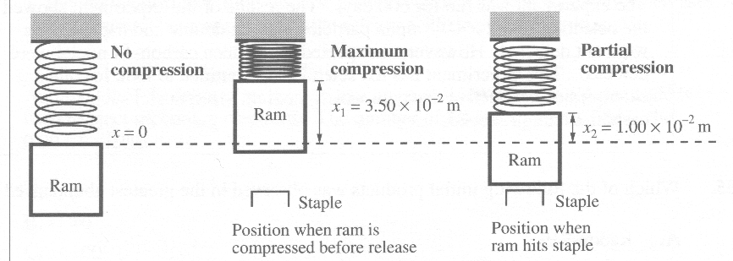
Heavy-duty stapling guns use powerful springs in combination with a small metal rod (called a ram) to produce the impact necessary to move staples or nails into materials such as wood, wallboard, or even concrete.

A particular staple gun has a ram with mass 0.200 kg and a spring with a spring constant of 35 000 N/m. When the handle of the gun is squeezed, the spring is compressed to a maximum value of 3.50 x 10⁻² m. When the ram makes contact with the staple, the spring is still compressed 1.00 x 10⁻² m. Assume that 3.00% of the ram's kinetic energy is transferred to the 2.00 g staple when the ram hits the staple. The potential energy of a spring is ½ kx².

1. Describe and calculate the energy transformations involved in the operation of the spring ram stapler. Use conservation laws, physics concepts, and related equations to support your answer. Ignore the mass of the spring and the effects of gravitational potential energy on the system.

(8 marks)

Use the following information to answer written-response question 2.

2. A student used the apparatus shown below to measure the radius of curvature of the path of electrons as they pass through a magnetic field that is perpendicular to their path. This experimental design has the voltage as the manipulated variable, the speed calculated from the voltage, and the radius as the responding variable.

Accelerating
Potential
Difference (V) Speed (10⁶ m/s) Radius (10⁻² m)
20.0 2.65 7.2
40.0 3.75 9.1
60.0 4.59 11.0
80.0 5.30 12.8
100.0 5.93 14.1
120.0 6.49 16.3

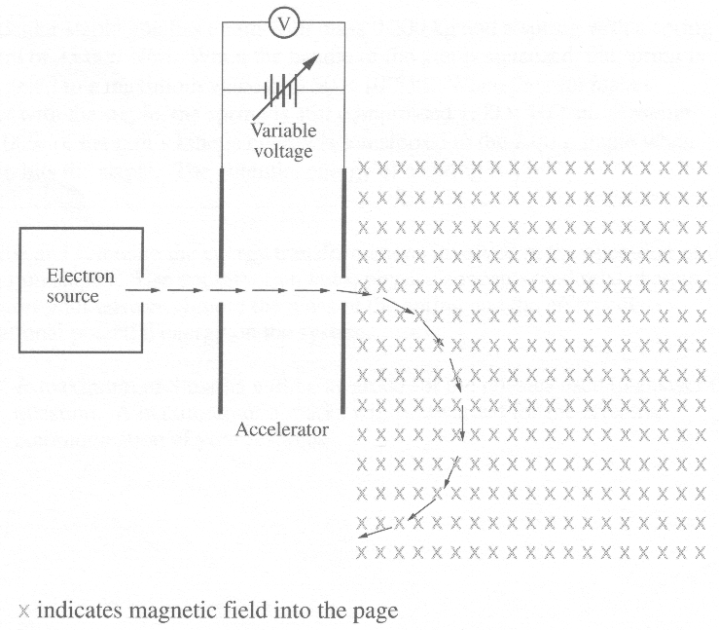

a. Plot the graph of radius as a function of speed, and construct a best-fit line.

(3)

b. Using the slope or other appropriate averaging technique, determine the strength of the magnetic field.

(3)

c. Derive the equation that would allow the student to calculate the speed of the electrons from their accelerating potential.

(2)

